F

P

R

1. Find the missing numbers in each sequence:
a) 0, -1, -2, ________, ________, ________
b) –3, –2, ________, 0, ________, _______
c) –9, –7, -5________, ________, ________

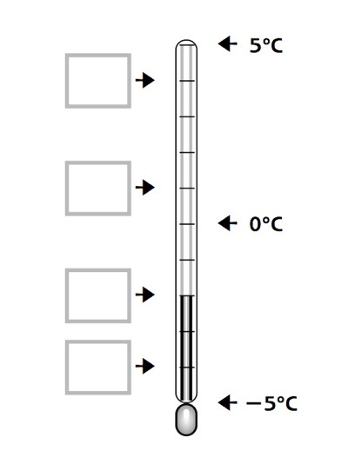
2. Put the four missing labels on the thermometer.

The temperature is -2°C.
The temperature rises by °1.
The new temperature is_______

The temperature is -2°C.
The temperature falls by 2°.
The new temperature is_______

The temperature is -2°C.
The temperature rises by 2°.
The new temperature is_______

3. Elliot is counting forwards in twos. He starts at –9.
Does he say ‘2’? Explain how you know.
____________________________________________________________________________________________________________________________________________________________________________________________________________

P

F

4. Look at the map showing temperatures at midnight.
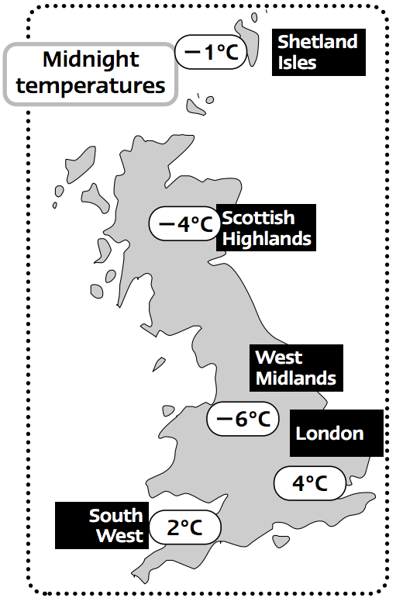
Which place has the highest temperature?
…………………….

Which place has the lowest temperature?
…………………….

Which is colder, the Shetland isles or the West Midlands?
......................

Which is hotter, the Scottish Highlands or London?
…………………..

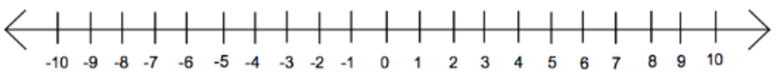
5. Using the temperatures on the map, place them on the number line below.

