Dividing with remainders

Copy the question neatly in your book and answer using short division.

1. 895 ÷ 5 =
2. 8,792 ÷ 7 =
3. 9,180 ÷ 6 =
CHALLENGE
4. 11,562 ÷ 3 =

PART 2
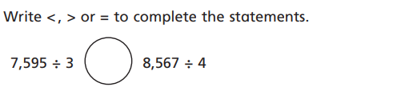
Show your workings neatly in your book,

PART 3
Mr. Hill is working out the answer to this word problem:

- Miss George’s PE bags hold 8 balls each.
- She has 1,851 balls.
- How many bags will she need?

He thinks the answer is 231 r 3.
Is he correct?
Yes / No, because….

TURN OVER

PART 2
Jonas is working out the answer to this word problem.
575 cakes are shared between 4 parties.
He writes two answers.
Which one is correct? Explain your thinking.
ANSWER 1: 575 r 3
ANSWER 2: 575.3
I think answer_____ because____________

