Year 1 home learning English w/c 6th April 2020
ENGLISH
Reading
Remember there are several online reading books available if you are struggling to find suitable books at home. Under Whole School resources in the Home Learning folder on the website are several links. This one is particularly useful for Year 1 Collins Big Cat e books (as we have Big Cat books in school)
https://connect.collins.co.uk/school/Portal.aspx
There is also a good app for early readers which is not very costly called Teach Your Monster to Read which some of you might find useful.
Phonics
Remember there is free access at home to https://new.phonicsplay.co.uk/
Username: march20 Password:home (phases 4 and 5)
The more adventurous of you might like to try this!
Nerf gun - or similar - and sound cards|!
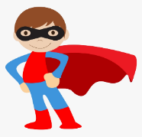
Writing
Write log entry number 2 Stay home Superheroes
What have you been doing? Did you make up any games to play?
Did you go for a walk? Did you join in with Joe Wicks?
Have you read a book, what was it about?
Tell us what you have been up to.

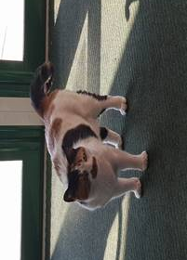
Look at the photo. This cat decided to come to school last week. Mrs Bryan had to persuade him to go home! Pretend you are the cat. What would you be saying? Why would you want to be coming into school? Write some sentences about your ideas. You could draw a huge cat shape and write your sentences inside it.





