Dear Reception children,
Thank you to everyone who has sent an email telling us what fun things you have been doing. It is lovely to read them all.

Well last week Mrs Watkins was very busy again working both at Wildlife Aid and then on Thursday and Friday in school with the ‘Keyworkers’ children. At Wildlife Aid Mrs Watkins worked with the fox cubs again, who are still growing very quickly. Sometimes she had to weigh the cubs twice as she was so amazed at how much weight they had put on. She was also able to help an injured pigeon and a crow, who were both very tricky to weigh. Then Mrs Watkins cleaned out a badger who had a nasty sore patch on his back. She had to be very careful and go in with another lady and a ‘walkie talkie’ for safety.
While at school Mrs Watkins worked with children from Reception class through to Year 6. We based our learning around the story ‘The Snail and the Whale’. We made a stained glass picture of the whale and the snail using coloured pasta. We wrote postcards as if we were the snail writing back to our snail families and made information booklets about snails and humped back whales.
Finally, again Mrs Watkins has been watching the garden birds. The Robins nest is still in the ivy plant on the garage wall and every time the mother and father bird fly in Mrs Watkins listens for the baby Robins crying for food. It is so exciting.
Remember to keep watching the fox cubs, the badger and the blue tits nest on
https://www.wildlifeaid.org.uk/webcams/
Mrs Bradshaw is still drawing every day and looking out for new flowers on her daily walks (some very rainy walks too). She loves taking photos and has noticed a lot of different insects and birds in her garden this week and even managed a photograph a bee flying towards a flower. It was looking for nectar and pollen. Mrs Bradshaw is keen to learn much more about bees and how important they are. What can you find out about bees?
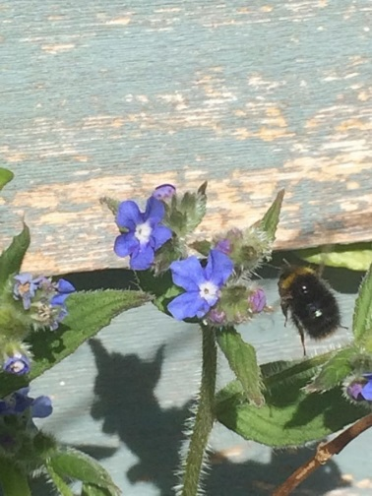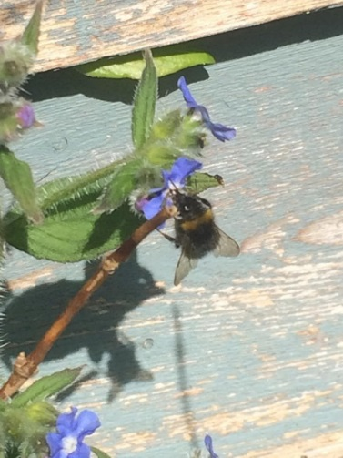
Can you spot any busy bees looking for a flower?
Mrs Bradshaw is really enjoying knitting her scarf and even though she made mistakes and had to start all over again she persevered and is glad she did because she is very pleased with it so far. She won’t be wearing it in the hot summer though. Maybe save it until the Autumn when it starts to get a bit colder.
Mrs Bradshaw is still waiting for her seeds to grow. She has planted even more in little pots and is watching them very closely for signs of life. She can’t wait to see how Mrs Watkins’ plants are coming along. Who will be able to grow the tallest plant or the biggest parsnip or the smallest carrot? Let’s wait and see…..Do you remember making pumpkin soup? Well, we saved all those pumpkin seeds and Mrs Bradshaw is going to plant some for you to follow as they grow. Have you planted any seeds?
Mrs Suggitt has been busy painting and decorating a wooden chest of draws. She has used copper leaf and gilding wax as well as paint. The copper leaf was very fiddly as it’s very thin and it took a lot of patience. She is very pleased with it now it’s finished. Have you made or decorated something you are really pleased with over the last few weeks?
She has been going for daily walks. One of her favourites is through the allotments near her house. An allotment is like a big field that has been divided and shared into smaller pieces of land that you can grow flowers, vegetables and fruits in. Different people look after each separate piece of land.
Mrs Suggitt wonders if any of you have heard about the amazing Captain Moore. He raised 23 million pounds for the Doctors and Nurses that are helping people to get better. He has been doing laps of his garden and lots of people have been sponsoring him to do this as everybody wants to help the Doctors and Nurses. It’s a very big amount of money. He is 99 years old! His birthday is at the end of this month, April. How old will he be on his birthday? Perhaps you could try and write that number! Captain Moore may have raised more than 23 million by the time you read this letter. You will probably need some help, but you could try and find out how much it is today. As a challenge you could try and write that number too!
Please all stay safe, happy and healthy, keep smiling! We can’t wait to see you all again soon.
From the Reception Team

