STEP 1: Write the answers you are sure of NEATLY IN PEN STEP 2: Now use an Atlas and your table partner to answer any questions you were not sure of NEATLY IN PENCIL
- Using what you can remember from your learning, identify these countries: NAME:_________________
USA, Canada
Brazil, Argentina
U.K, Spain
Russia, China
Australia, New Zealand
Map showing the countries of the world
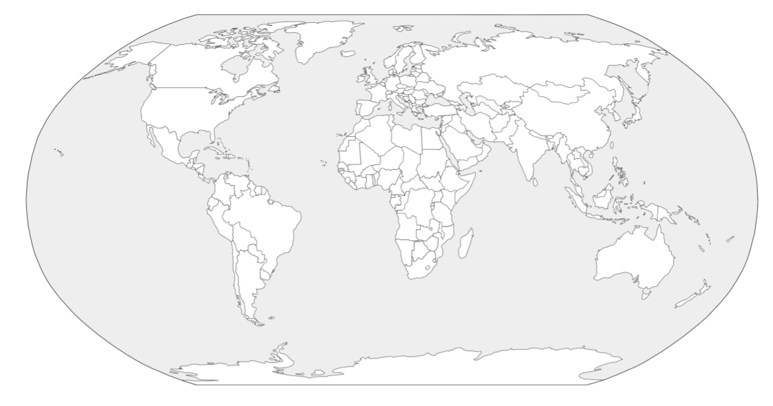
What is the equator?

What are the Tropic of Cancer and Tropic of Capricorn?

With a ruler, draw on the Prime Meridian

