Please

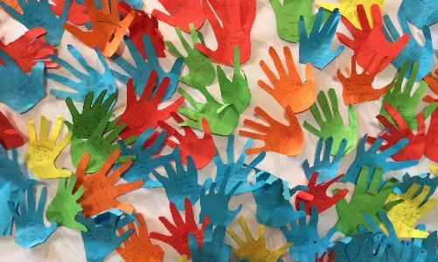
- Is there something that you are worried about; something that you want God to help you with?
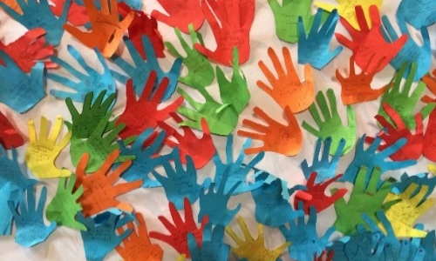
- On a piece of coloured paper and draw around your hand.

- On your hand shape write or draw the thing that you want to put into God’s hands.

- Cut out your hand shape.

- When your teacher tells you to, go and stick your hand prayer onto the big paper to make a class banner of prayers.

Please

- Is there something that you are worried about; something that you want God to help you with?
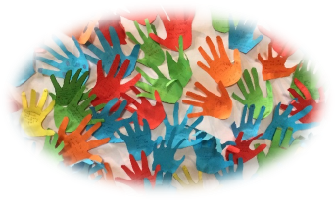
- On a piece of coloured paper and draw around your hand.

- On your hand shape write or draw the thing that you want to put into God’s hands.

- Cut out your hand shape.

- When your teacher tells you to, go and stick your hand prayer onto the big paper to make a class banner of prayers.

Please

- Is there something that you are worried about; something that you want God to help you with?

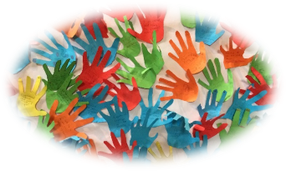
- On a piece of coloured paper and draw around your hand.

- On your hand shape write or draw the thing that you want to put into God’s hands.

- Cut out your hand shape.

- When your teacher tells you to, go and stick your hand prayer onto the big paper to make a class banner of prayers.

