

**Holiday Brochure Plan**

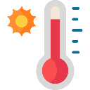

Conclusion – a final attempt to persuade your reader!

Attractions e.g. sightseeing, museums, theme parks, shops, outdoor adventure activities

Weather

Accommodation

Facilities e.g. swimming pool, gym, parking, air conditioning

Introduction – where is the holiday destination? What makes it beautiful or special? Use powerful vocabulary to describe it and hook your reader.