**Missing Addends \*\***

**Success Criteria**

Your steps to success for this next mission are:

1. Count up to find the missing numbers.
2. Write on ALL exchanged numbers.

**WARM UP ☺**

|  |  |  |  |
| --- | --- | --- | --- |
| 1. | 4 | 2 | 5 |
| + |  | 3 |  |
|  | 5 |  | 7 |

|  |  |  |  |
| --- | --- | --- | --- |
| 2. | 7 |  | 2 |
| + | 2 | 4 |  |
|  |  | 8 | 9 |

**Challenge 1**



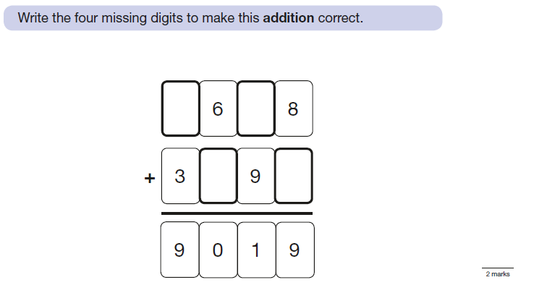

Use this space for working out:

**Challenge 2**

