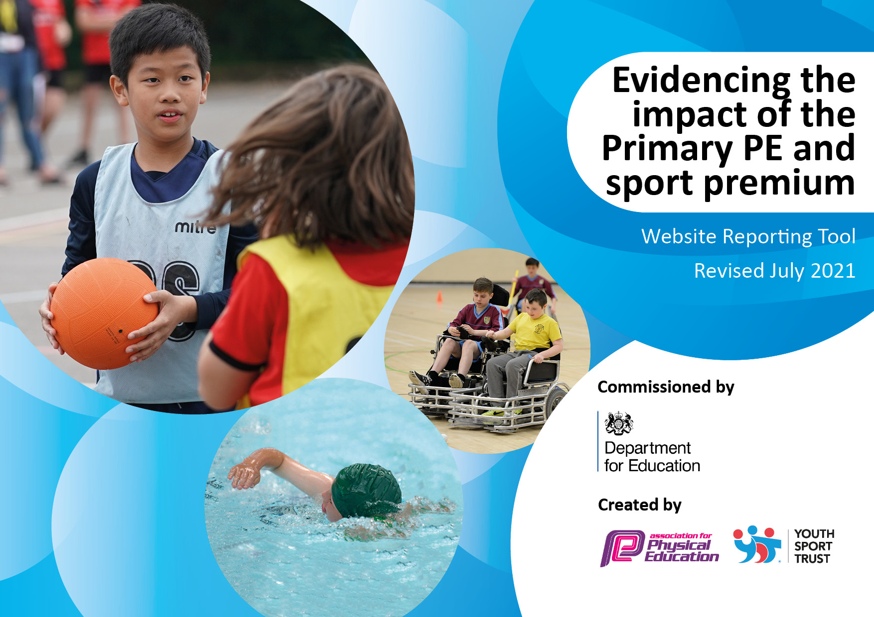T

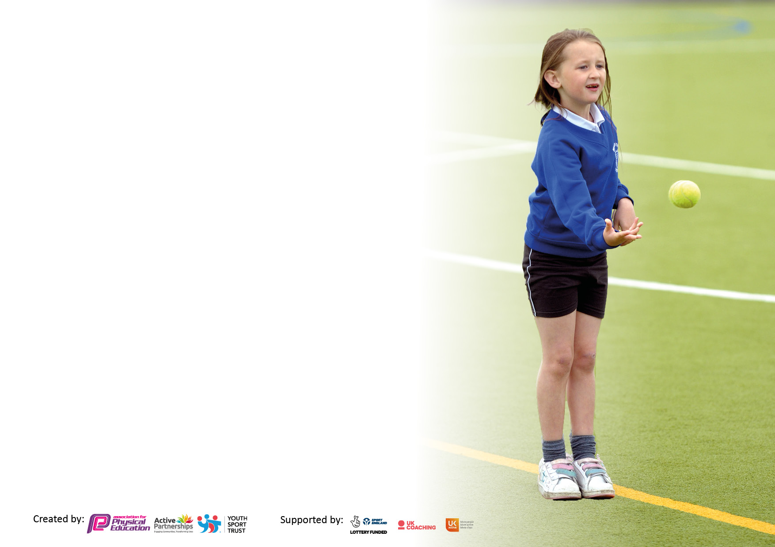

It is important that your grant is used effectively and based on school need. The Education Inspection Framework makes clear there will be a focus on **‘whether leaders and those responsible for governors all understand their respective roles and perform these in a way that enhances the effectiveness of the school’**.

Under the Quality of Education Ofsted inspectors consider:

**Intent** - Curriculum design, coverage and appropriateness

**Implementation** - Curriculum delivery, Teaching (pedagogy) and Assessment

**Impact** - Attainment and progress

To assist schools with common transferable language this template has been developed to utilise the same three headings which should make your plans easily transferable between working documents.

Schools must use the funding to make **additional and sustainable** improvements to the quality of Physical Education, School Sport and Physical Activity (PESSPA) they offer. This means that you should use the Primary PE and sport premium to:

* Develop or add to the PESSPA activities that your school already offer
* Build capacity and capability within the school to ensure that improvements made now will benefit pupils joining the school in future years
* The Primary PE and sport premium should not be used to fund capital spend projects; the school’s budget should fund these.

Pleasevisitgov.ukfortherevisedDfEguidanceincludingthe5keyindicatorsacrosswhichschoolsshoulddemonstrate animprovement.Thisdocumentwillhelpyoutoreviewyourprovisionandtoreportyourspend.DfEencouragesschools to use this template as an effective way of meeting the reporting requirements of the Primary PE and sport premium.

We recommend you start by reflecting on the impact of current provision and reviewing the previous spend.

Schools are required to publish details of how they spend this funding, including any under-spend from 2019/2020, as well as on the impact it has on pupils’ PE and sport participation and attainment. **All funding must be spent by 31st July 2022.**

We recommend regularly updating the table and publishing it on your website throughout the year. This evidences your ongoing self-evaluation of how you are using the funding to secure maximum, sustainable impact. Final copy must be posted on your website by the end of the academic year and no later than the 31st July 2021. To see an example of how to complete the table please click HERE.

Created by: Supported by:

**Details with regard to funding**

Please complete the table below.

|  |  |
| --- | --- |
| Total amount allocated for 2022/2023 | £ 16,000 + £10 per pupil (360) + £3,600 (£10 per pupil (£3600) |
| Total amount allocated for 2022/23 | £19,600 |

|  |  |
| --- | --- |
| Total amount spent for 2022/2023 | £18,216.90 (92.95%) |
| Total amount carried forward to 2023/2024 | £1383.10 (7.05%) |

**Swimming Data**

Please report on your Swimming Data below.

|  |  |
| --- | --- |
| Meeting national curriculum requirements for swimming and water safety.  N.B. Complete this section to your best ability. For example you might have practised safe self-rescue techniques on dry land which you can then transfer to the pool when school swimming restarts.  **Due to exceptional circumstances priority should be given to ensuring that pupils can perform safe self rescue even if they do not fully meet the first two requirements of the NC programme of study** |  |
| What percentage of your current Year 6 cohort swim competently, confidently and proficiently over a distance of at least 25 metres?  **N.B.** Even though your pupils may swim in another year please report on their attainment on leaving primary school at the end of the summer term 2023. Please see note above | 97% |
| What percentage of your current Year 6 cohort use a range of strokes effectively [for example, front crawl, backstroke and breaststroke? Please see note above | 97% |
| **What percentage of your current Year 6 cohort perform safe self-rescue in different water-based situations?** | 97% |
| Schools can choose to use the Primary PE and sport premium to provide additional provision for swimming but this must be for activity **over and above** the national curriculum requirements. Have you used it in this way? | Yes - A week intensive course for all children in Year 5 and 6 who had not met the 25m requirements. Due to COVID years, these numbers were higher than usual with 16 children taking part in this intensive course. Out of the 16 children, 14 children achieved 25m or more plus lifesaving skills by the end of the week. |

**Action Plan and Budget Tracking**

Capture your intended annual spend against the 5 key indicators. Clarify the success criteria and evidence of impact that you intend to measure to evaluate for pupils today and for the future.

|  |  |  |  |  |
| --- | --- | --- | --- | --- |
| **Academic Year:** 2022/2023 | **Total fund allocated: £19,600** | **Date Updated: January 2023** | |  |
| **Key indicator 1:** The engagement of all pupils in regular physical activity – Chief Medical Officers guidelines recommend that primary school pupils undertake at least 30 minutes of physical activity a day in school | | | | Percentage of total allocation: |
| 28.32% |
| **Intent** | **Implementation** | | **Impact** | £5552.24 |
| Your school focus should be clear what you want the pupils to know and be able to do and about  what they need to learn and to  consolidate through practice: | Make sure your actions to achieve are linked to your intentions: | Funding allocated: | Evidence of impact: what do pupils now know and what can they now do? What has changed?: | Sustainability and suggested next steps: |
| To encourage more children to get involved in activities before school at breakfast club and within lessons to increase focus of children.  To continue to get all pupils undertaking at least 30 minutes of additional activity per day, using the mile a day track as well as using this as a self-challenge activity at least 1once per half term.  To raise the profile of active transport to school using travel tracker  To engage all pupils in physical activity (in line with the government target to engage all pupils in an extra 30 mins exercise per day)  To develop a Year 6 **Sports Crew** to lead some activities at lunch time play and help with whole school charitable festivals and challenge festivals.  To **train lunchtime staff** to increase the confidence in leading active play  Lunch staff had the training for **Physifun** but just need to be reminded regularly of the course and the PhysiFUN cards need to be available in the staffroom for ideas.  To help those with a talent in leadership to develop these skills and to take this knowledge into secondary school  **Increase activity** during curriculum **lessons** by increasing equipment available to the children | To allocate a staff member to undertake activities and update subscription to **Jump Start Jonny**  To give updates and CPD for staff (new and old) to increase confidence with the use of the **running track** and how this can be implemented into the school day as **active bursts**.  To do 3 x yearly assessments to identify less active and to target these children into taking part in active play and festivals.  To set up **challenge days** so children can complete timed activities and try to improve their own score (activities eg skipping, target throwing) – purchase challenge equipment for a challenge area to take place during lunch times.  To monitor how children get to school and raise the profile of active travel. To continue to use **Travel Tracker** to ensure that each child in the school is monitored.  To train 10x Year 6 children on **Active Surrey Sports Crew training** Course.  Set up a Sports Crew lead to help facilitate and organise activities for all year groups at lunch time.  For sports Crew to help with Charitable activities including Children in Need, Comic Relief etc.  To ensure **lunch time staff / Sports Crew** are able to use the outdoor portable speaker system so each lunch time there is a ‘music’ zone to promote dance and activity.  Lunch staff need to be reminded regularly of the course and the PhysiFUN cards need to be available in the staffroom for ideas.  To train 2 children from year 6 to be **Gifted and Talented Young Leaders**  To give regular training **to lunchtime staff** to give them an increased confidence of leading activities during the lunch hour, using physic-FUN activities and playground markings.   * Monitor impact on lunch time play   and allocate key active roles within the playground.  To give further **equipment for lunchtimes**   * wobble boards (had enough) * Bouncy hoppers (had enough) * Target boards * Stilts (had enough) * Hoops/floor spots (had enough) * Basket ball/netball shooting * Skipping (had enough) * PhysiFUN equipment (Fit bags) 5 x £165 * PhysiFUN cards x2   Purchase additional equipment for curriculum sessions (whilst there is enough equipment for curriculum lessons, to purchase further equipment will allow all children to be continuously active within lessons rather than sharing, with a **focus on adapted equipment for those with SEND** | £289  £250  £0  £186  £225  £0  £250  Not being used.  £200  £135 dodge balls  £4267.24 | Jump start Jonny has had a huge impact for children in breakfast club, as they use this just before they go to class. Children are ready to learn after being energised  Teachers have taken an audit and key areas have been identified to ensure all teachers are confident with taking curriculum and club sessions.  Challenge days give children the opportunity to challenge themselves to gain personal bests. Children really engage in this and we have seen a higher percentage of activity during playtimes off the back of these sessions, especially during our sipping personal best challenges  Intra competitions have taken place, giving children a form of competitiveness , where they have been practising in play times  Instead of having a yearly subscription to living streets, we chose to complete a walk to school week.  Sports Crew – completed 2 charity events to raise active lessons  Lead warm ups in lessons and then other children in the class learn from them and start to also lead the warm up.    Public speaking and being a role model  Marketing and promotion  Pupil voice  Inclusive activity  Due to our surplus we will fund this in 23/24  Did not buy this year but would like to implement this next year  **Curriculum:**  Netball bibs £63.18  Footballs £175.79  Rewards stickers lunchtime £114.95  Hockey ankle guards for PP children £20  Lacrosse balls £37.27  Gym mats £359.95  Ball pumps £117.16  Rugby tags £52.95  Basket ball nets and boards £1560.60  Tennis balls £190  Sport shed £1575.39  With more equipment, it has meant that there is higher activity within the class lessons as each child has access to the equipment at all times so there is no/limited waiting. The school SIP was impressed with the amount of equipment and that all children could take part with no sharing of equipment | These active breaks are now embedded into our curriculum  Teachers are far more confident with this and these active bursts are used on a daily basis in all year groups  As these personal best challenges take place regularly children are engaged and continue to try to gain personal bests even after the specific sessions, increasing active time.  This year, challenge lunchtimes were lead by the Sports Crew, giving lunch times a active focus for more children. Children enjoy challenging themselves and this has been very positive.  Children across the school choose an active way to come to school. Across KS1 and 2 over 90% of children come and go from school in an active way. We used a week focus to celebrate our active travel and help those who do not travel actively to use the park and stride method to increase activity. Active travel is praised and embedded into St Paul’s culture.  Sports Crew have been out daily as active ambassadors to encourage those who are less active during these periods of time to take part in fun active activities, with the use of PhisiFUN activities. Friday lunch time has also become Music Friday, where children can enjoy music and dance on the playground. This has been a great success.  *For 2023/24*  *Continue the provision to include year 5 leaders (Active Surrey Training) to ensure in future years that they can become mentors for the new year 5s each year, therefore making this a more sustainable provision.*  Josie and Molly entered this leadership programme and submitted their application However this programme is no long taking place as Active Surrey cancelled this event.  Due to high turn over of lunch staff, this has not been full implemented, however, those staff who have been a constant this year, have worked very hard to ensure higher activity during lunch times.  Children are more active as they do not need to wait a turn for equipment as there is enough equipment for all children to be active all the time during curriculum session.  We have increased equipment for gymnastics and with this we have been able to provide gymnastics club throughout the year with more equipment to increase club size and frequency |

|  |  |  |  |  |
| --- | --- | --- | --- | --- |
| **Key indicator 2:** The profile of PESSPA being raised across the school as a tool for whole school improvement | | | | Percentage of total allocation: |
| 12.6% |
| **Intent** | **Implementation** | | **Impact** | £2465 |
| Your school focus should be clear what you want the pupils to know and be able to do and about  what they need to learn and to  consolidate through practice: | Make sure your actions to achieve are linked to your intentions: | Funding allocated: | Evidence of impact: what do pupils now know and what can they now do? What has changed?: | Sustainability and suggested next steps: |
| **To maintain a strong partnership between the Dorking schools and being a member of the**  **Dorking Schools Sports Partnership**  **To maintain a strong understanding of School Sport through membership from Active Surrey**  **Role models – local sporting personalities so pupils can identify with success and aspire to be a local sporting heroes.**  **To maintain out Platinum Sports award for KS2**  To raise profile of sport through updating the website and school notice board regularly  To raise the **awareness of mental health** with children across the school  to continue to **develop outdoor learning** curriculum and knowledge | Employment of Schools Sports Partnership   * Provide updates in PESSPA * Develop PE subject leadership * Provide updated planning for key areas * Participate fully in the wide DSSP calendar of festivals and competitions   Invite a local sportsperson into school in the spring/summer term to inspire children to stay active  Ascertain which local personalities the pupils relate to and invite them into school  To maintain assessments for all year groups, update planning, record achievements, competitions. To be aware of the criteria for both awards and ensure that the requirements are met throughout the year.  To ensure children are celebrated to the wider community through the website/social media.  To give time for the website to updated with sports reports and achievement and ensure different children write up reports for festivals, personal vert challenges and competition. Include photos and update the sports board with these reports as well as the website.  To create Termly updates through News Letters for all parents.   * Yoga/stretching * Up-beat active sessions and mindful movement and discussions   INSET day September for Year Group Leads with **SOLD.**   * Aim to do at least one **active outdoor lesson per week** | £1,100  £125  £0  £600 staff cost  £500  Imoves  £140 | PE lead remains up to date with all developments in PE  Ex Royal Ballet Dancer (TA within school) completed sessions for Year R to Year 6 focused on ballet – practise and perform.  Ex St Paul’s School child to inspire women’s football and bring current women’s football stars from Dorking Wanderers to inspire and promote the sport for all.   * Royal Ballet Day – sessions for Year R to Year 6   Football – woman footballer who used to attend St Paul’s school and has got many caps for England to have an inspiring assembly for all and activities which will be led by Pauline and helped by Local women’s team –  We have again achieved the highest award for sport, The Platinum Award.  Attend Games marks and sports premium workshops.  See key indicators.  Time is given to sports reporters to write up the sports reports for each active event that takes place at St Paul’s. Children who do not have the confidence to go to clubs due to it being a new environment are invited to write a report by attending the competitions.  The imoves subscription has help us achieve this with their mindful times and active bursts  To give teachers and support staff confidence to bring curriculum learning to the outside. | We have regular CPD meeting for the Sports Lead and the Employment of Schools Sports Partnership ensures that we have a full competition schedule in conjunction with the other Dorking Schools to inspire and engage those less active as well as ensure fair competitions for the teams. 78.3% of all KS2 children took part in sports clubs this year with 60% representing the school in festivals or competitions.  All children from Year R to Year 6 had an opportunity to take part in ballet sessions with an Ex Royal Ballet Dancer. Children we in awe of how it is possible achieve highly in sport with our school values (perseverance, determination, hope, wisdom)  Year 5 and 6 took inspiration from a local capped footballer and the Mole Valley Football Team, understanding that women in sport can achieve highly and that there is equality in sport. All children in St Paul’s know that anyone can achieve using the values of our school (perseverance, determination, hope, wisdom, respect)  We have again achieved the highest award for sport, The Platinum Award.  Targeted children are becoming more active and choosing to come to more clubs  By giving children the opportunity to go to events without competing has given them he confidence to try new sports at school during club sessions, increasing whole school activity.  Children are celebrated in school and on the website which raises the profile of sport and encourages others to come to more clubs. All clubs are free and can be accessed by all.  Children enjoy being photographers and reporters for events and parents and children are more aware of the sporting achievements in school.  Children are becoming more aware on how they can help their mental health, using relaxation and mindful strategies.  Teachers are far more confidence with using the outside classroom and they have used the strategies and ideas outlined in the training to make learning more engaging and active. |

|  |  |  |  |  |
| --- | --- | --- | --- | --- |
| **Key indicator 3:** Increased confidence, knowledge and skills of all staff in teaching PE and sport | | | | Percentage of total allocation: |
| 12.1% |
| **Intent** | **Implementation** | | **Impact** | £2367 |
| Your school focus should be clear | Make sure your actions to | Funding | Evidence of impact: what do | Sustainability and suggested |
| what you want the pupils to know | achieve are linked to your | allocated: | pupils now know and what | next steps: |
| and be able to do and about | intentions: |  | can they now do? What has |  |
| what they need to learn and to |  |  | changed?: |  |
| consolidate through practice: |  |  |  |  |
| To provide targeted CPD in PE to provide staff opportunities for professional development.  To provide **further progress and achievement** for all pupils in **dance and gymnastics**.  To **monitor** and continue to develop the **teaching of dance**  To provide a tighter progression plan from Early Years to KS1 | To identify staff who are in need of further CPD using the staff audit at the start of the year and provide personalized CPD opportunities for them. Sports lead to have time to correlate results and implement actions identified through Audit  ECT – Gym course through Active Surrey  ECT – Behaviour management in Sport  Imoves – increase the subscription to include Fundamentals of Sport in Early Years and KS1 to provide variety and progression.  **Dance:**   * Continue subscription with Imoves, a resource to provide lesson plans / music / videos for dance lessons that are active and shows a progression of skills. * Monitor Teaching and pupil progress in dance. * Identify and support staff lacking confidence in using this resource. * Keep records of dance units taught.   *To continue into 23/24 – use of assessment document to help monitor progress*   * To run an interclass strictly competition? * KS1 dance club during lunch time   **Gym:**   * Provide **training** to all teachers on how to safely use **apparatus** and provide ongoing help for those who need further help. * Work with less confident teachers and ECT * **Monitor progress and teaching** of **gymnastics** | £1000  £45  £125  £997  £200 | Teachers have taken an audit and key areas have been identified to ensure all teachers are confident with taking curriculum and club sessions.  Identifies staff have been given the opportunity to team teach to gain further confidence and subject knowledge for the PE topics they teach. Staff have also been given time by the PE/Sport lead to mentor and support them.  £45 Gym training external  Teachers were given time to complete the online CPD sessions associate with imoves and had time set aside in staff meetings to discuss their learning and raise questions with the PE lead and other teachers  All staff were given training at the start of the year to ensure they understood how to safely set out the gym apparatus | This ensures that all staff are becoming more confident with teaching PE and that the quality of teaching PE across the school is high.  The use of imoves has increase the quality of dance teaching across the school.  Staff are more confidence with setting out the apparatus correctly and how to manage the classes to ensure that apparatus is set out in a timely manner, safely to ensure more time used on active learning. Staff are now able to progress the learning from the floor to the apparatus. |

|  |  |  |  |  |
| --- | --- | --- | --- | --- |
| **Key indicator 4:** Broader experience of a range of sports and activities offered to all pupils | | | | Percentage of total allocation: |
| 16.5% |
| **Intent** | **Implementation** | | **Impact** | £3235 |
| Your school focus should be clear | Make sure your actions to | Funding | Evidence of impact: what do | Sustainability and suggested |
| what you want the pupils to know | achieve are linked to your | allocated: | pupils now know and what | next steps: |
| and be able to do and about | intentions: |  | can they now do? What has |  |
| what they need to learn and to |  |  | changed?: |  |
| consolidate through practice: |  |  |  |  |
| To **embed** our new **broad and varied curriculum** to reflect our school and PE curriculum aims.  To ensure the curriculum follows a clear progression of skills.  To run **additional swimming** sessions for all **Year 6** children **not achieving** the expected level by summer term.  To target any groups of children of less active children with additional free clubs and opportunities including inter school festivals  To develop a larger range of clubs for all age groups to get more children involved in new active experiences.  To inspire children to keep active and try other types of events and be inspired by local sporting greats.  To inspire less active as well as the whole school community to become more active by giving a broader range of sports and activities offered to the pupil | **Monitor long term** planning to ensure that it is being followed.  Order **additional equipment** to enhance curriculum so it is taught effectively and enables differentiation of skills  Ensure sufficient equipment for all to be active.  Identify weak swimmers in Year 5 and 6 and set up additional term of booster sessions for those children in the summer term.   * Panathlon (SEND and less active – January 2023) * PhisiFUN festival * Develop and increase the sports clubs offered before school, during lunch times and after school * To work with external clubs especially for KS1. Dance for Year 2 * PE lead to support staff to lead clubs for at least 1 term each per year to ensure a variety of clubs all year round * Attendance record for children taking part in clubs and competitions to help identify those less active and promote club attendance for those. * Street Dance – inspiring activity festival September 2023 * Quidditch festival to tie in with World Book Day 2024 (booked in February 2023) * Local secondary school to lead active inspiration day | £800  (see previous indicator)  £750  £100  £100  £250  £300  £935  £0 | The PE lead has ensured that there is a board curriculum with clear progression for the children.  There were 16 children identified in both Year 5 and 6 who were either unable to complete 25m or had not gained lifesaving skills. These children were given a week’s worth of intensive swimming training.  Children have been inspired to be more active by attending festivals through Penthalon or PhysiFUN  Children in KS2 have been given opportunities to take part in numerous clubs over the year, all free of charge, either before school, during lunch times or after school. All children are welcome.  There have also been selected clubs for KS1 too, although this needs to be developed further to ensure a higher range available to them  Completed for each year group for both clubs and competitions. This means we can identify less active children and target them for festivals and other inspiration sessions  Did not happen  Children form the local secondary school (some of whom attended St Paul’s when they were in primary school, lead activities for children to enjoy | The curriculum is broad and progresses through the year. The progression documents allow teachers to understand previous years learning so that they are able to ‘throwback’ to question children on previous learning and build on this. Teachers are also aware of where the learning progresses into future years.  This has been a real success, having non-swimmers, after 10 weeks gain their 25m badge. From the 16 children identifies, 14 children are now able to complete 25m or more and have been given basic lifesaving skills.  2 children in year 5 will complete the course again next year to help them achieve the minimum requirement.  The PhysiFUN team (less active children) attended the county finals and came 1st giving the children more inspiration to try new clubs. Since this club, 5 out of the 8 children have gone on to take part in rounders club and 1 children went to tennis club and got selected to represent the school in the competition.  We have had clubs for:  GreenPower (motor sport/engineering)  Football  Lifesaving  Netball  Rounders  Hockey  Sports Hall Athletics  Athletics  Cricket  Tennis  Rugby  Gymnastics  Dance  Cross Country  Golf  A variety of teachers take these responsibilities on with the support of the Sports Lead.  78.3% of all children in KS2 attended one ore more different sports club this year with 60% of those representing the school in competitions or festivals.  These activities inspired children to use these active games during their lunchtimes and play times after the event. |

|  |  |  |  |  |
| --- | --- | --- | --- | --- |
| **Key indicator 5:** Increased participation in competitive sport | | | | Percentage of total allocation: |
| 23.5% |
| **Intent** | **Implementation** | | **Impact** | 4597.66 |
| Your school focus should be clear | Make sure your actions to | Funding | Evidence of impact: what do | Sustainability and suggested |
| what you want the pupils to know | achieve are linked to your | allocated: | pupils now know and what | next steps: |
| and be able to do and about | intentions: |  | can they now do? What has |  |
| what they need to learn and to |  |  | changed?: |  |
| consolidate through practice: |  |  |  |  |
| Additional achievements:  To bridge sport with science and technology  To provide extra clubs to give a broader range of activities for children, especially those who are less active and PP/FSM.  Increase opportunities for KeyStage 1 competitions | GreenPower – motor sport kit car building and racing. To run a club for the less active, pupil premium, SEND and other children showing promise in engineering so children can experience a different sport.   * Invite target group * Run an early morning club * Equipment purchase * Transport   Competition fees   * To provide further activities for children who are less active and PP * Certificates and medals for festivals and sport competitions * Staff costs for attending sports competitions, CPDs and sports festivals. To ensure that children are safe and have the ability to be able to attend festivals, training and competitions. * Cost of training for sports competitions * Purchase spots awards /trophies * Enter and train for all sports events. * Look at active surrey festivals for the less active. * Track and field * Dance (Sabina) afternoon   Key steps Gymnastics Year 1 and 2 | £400  £50.60  £5.06  £600  Sports Hall comp £80  Cross country fee £12  Engraving £50  £3400 | Targeted children have learnt life skills through team work and also learnt STEAM. Children have been really engaged and they competed nationally against 65 other schools  Gym club has continued for the whole year allowing more children to take part for longer, netball club has increased from 1 term to 2 terms. More sports clubs have been available during the school day so more children are able to access the clubs  Panathlon  PhysiFUN  Going to a wide variety of events gives more opportunities to the children. These are celebrated and inspire more children to become active and try new sports/activities.  We are bringing in a KS1 gym competition next year to give more opportunities to the KS1 children to compete | GreenPower have a big presence in the school to promote green travel and also inspire other children to take part in motorsport/engineering as they grow up.  The GreenPower team took part in an internation event at Goodwood Motor Circuit coming 22/71 cars taking part. They won awards for Best bodywork and have got further confidence to take this learning further in the future.  More PP and SEND and less active have been targeted to go to clubs and have also taken part in competitions.  We have taken part in 24 competitions, 16 of those we can in the top 3. WE have gone to 3 county finals and won awards at 2 of those county finals.  Staff costs due to being able to take a high number of children to so many events through the year, giving more opportunities to a wider range of children. 78.3% of children went to sports clubs this year with 60% representing the school. |

|  |  |
| --- | --- |
| Signed off by | |
| Head Teacher: |  |
| Date: | 20/7/2023 |
| Subject Leader: | Miss George |
| Date: | 20/7/2023 |
| Governor: |  |
| Date: | 21/07/2023 |