SC: I know that muscles help your body to move
I know that muscles contract and relax
I know that muscles are attached to the bone
I know that muscles work in pairs
I know that some muscles work involuntarily (e.g. the heart) and that some you have to make move

How skeletons move
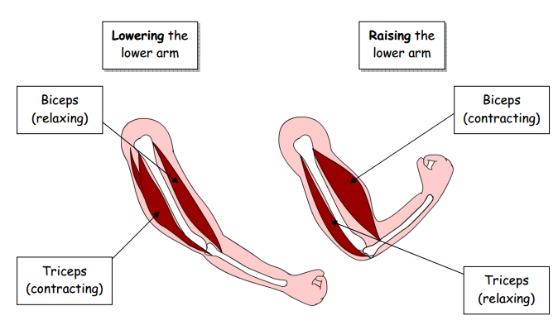

Complete the following statements:
Muscles are attached to bones in pairs.
When a muscle contracts it gets shorter and fatter, so pulls on the bone it is attached to.
When a muscle relaxes, it goes longer and thinner.
Lots of muscles in your body you can make move when you want to but some muscles are involuntary (they happen automatically), for example the heart.

Keywords:
longer shorter thinner fatter bones
heart contracts pairs relaxes

