SPORTS REPORT EASTER 2015

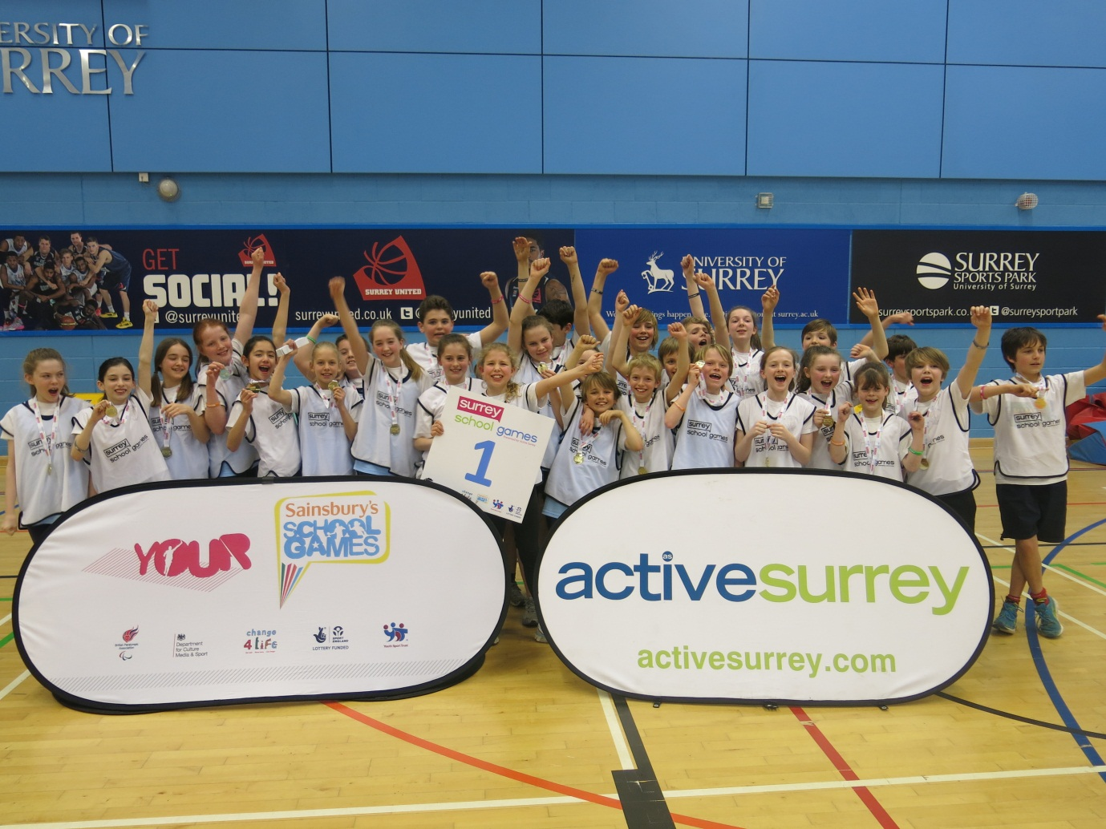
CONGRATULATIONS to the Year 5 and 6 Sporthall Athletics team who WON the COUNTY CHAMPIONSHIP held at Surrey Sports Park last week! To qualify the team had won the Dorking competition and then beaten a strong Leatherhead team to reach the finals. The 30 children -15 girls and 15 boys competed in 6 track and 6 field events against 11 other District Champions from all over Surrey. It was a very exciting afternoon with a high standard of performances, our team were 8 points behind the leaders with only, javelin, relay and speed bounce to take place and they managed to win by 6 points!
Congratulations also go to our Tag rugby and Hockey teams who have both reached the County finals.
We entered 2 teams in the Dorking tag rugby competition held at the ‘Big Field’ in Brockham All schools took part in a very closely contended competition. Our ‘B’ team came 5th and the ‘A’ team came 2nd going on to the County final at Surrey Sports Park on 15th April with the winning team North Downs.
We also entered 2 teams in the Surrey Schools South East and West quicksticks finals at Reigate Grammar sports ground. Our teams enjoyed playing matches on such excellent pitches. The teams both reached the South West finals where they played each other and drew 0-0. Instead of going to penalties we decided to select one team from the two squads to go forward to the county finals in July.

The Year 6 netball team took part in the Dorking tournament where they played well winning all but 1 of their matches. They drew on points with the Weald for 2nd place but were placed 3rd on goal difference. St Martins won and go forward to the County finals.
The year 5 team also played in the Dorking schools tournament and finished 4th there attacking play was excellent but need to work on their defending for next year.

We had a good turnout for the 2nd league cross country race at the Weald recently, with over 50 children from year 3, 4, 5 and 6 taking part. Our teams are currently placed 4th in the year 3/4 and 3rd in year 5/6 age groups and 4th overall.
Sports Clubs for the Summer Term

Summer Term  2014 | Monday | Tuesday | Wednesday | Thursday | Friday
Lunchtime | Yr 5 and 6  Athletics | Year 4/5/6 Athletics | Yr 5/6 boys cricket | Yr 3/4 Rounders  Year 3/4 Change 4 Life club | Yr 5/6  Rounders
Afterschool  3.20-4.20 | Yr 4/5/6 Girls Cricket | Yr 1 and 2 ‘Little Sports Stars’  Multi skills  Club TBC |  | All Years Chelsea Football

