Dear Reception children,
Thank you to everyone who has sent an email telling us what fun things you have been up to. It is lovely to read them all and to see the photographs and pieces of work. It is also great that so many of you have been busy on ‘Purple Mash’, lots of lovely paintings, writing and photographs. Some of you have had a go at using ‘2create a story’ and it looks like you are enjoying that too. Some of you have been using ‘Doddle Maths’, this is brilliant too.

Well, last week Mrs Watkins was very busy again at Wildlife Aid and worked with the garden birds, some of whom are still so tiny, and others now trying to escape. She also worked with the fox cubs and badger cubs all of whom are growing well, putting on lots of weight and still doing lots of play fighting. This week we also had many baby ‘Corvids’ in as orphans. Corvids are the name for birds of one type including magpies, crows and jackdaws. In hospital 2 on Monday we had a baby Crow who, although very young, was still quite big and ate lots of food from tweezers. There were about ten baby Magpies all who also had to be fed with food from tweezers and then needed cleaning out as they were very messy. Mrs Watkins was also lucky to be able to weigh, clean out and feed three baby Tawny Owl chicks, they are just like the three owls in the story ‘Owl Babies’.
Remember to keep watching the fox cubs, the badger cubs and the blue tits nest on
https://www.wildlifeaid.org.uk/webcams/
At home Mrs Watkins has been doing lots of cleaning and was very excited as her youngest son, Callum, came home from Swansea University. Mrs Watkins had to get his bedroom tidy and make sure he had clean bed sheets on his bed. She also made his favourite dinner – roast chicken and had to be ready for the bags and bags of washing he brought home!
Mrs Watkins has also been looking at a website about ‘Hedgehog Awareness Week’ https://www.britishhedgehogs.org.uk/hedgehog-awareness-week-2020-3rd-may-9th-may/ She found lots of ways to help keep hedgehogs safe. Did you find out anything about hedgehogs during that week?
Finally, Mrs Watkins worked in school, which she loved and was able to help lots of children with the topic ‘All kinds of buildings’. In school we looked at insects and the types of places they like to live and have started a school ‘Bug Hotel’ which was great fun.

Mrs Suggitt is pleased to say that the grass her family planted for the grass growing competition has started to shoot. This now means that they have to all work really hard to keep the grass watered, especially if we do not have much more rain. She is happy that a clematis plant is growing beautifully up her fence. The clematis plant is a climber. This is because as it grows up a fence or wall it clings and grows upwards. It can also grow sideways if it has something to climb across! Mrs Suggitt thinks it’s very clever that plants can do this.
Mr Suggitt has set up a stationary bike in their garden. Mrs Suggitt has been going on it every day. At the start Mrs Suggitt could only do 15 minutes, but is now able to do 45 minutes. She is challenging herself to be able to do one whole hour without stopping!
This week Mrs Suggitt thought she would tell you about her two lovely family cats. One is called Bear and one is called Tia. They are brother and sister. They are always very kind to each other and they play really well together. Although Bear can sometimes be a bit cheeky and eats more than his fair share of their cat food!
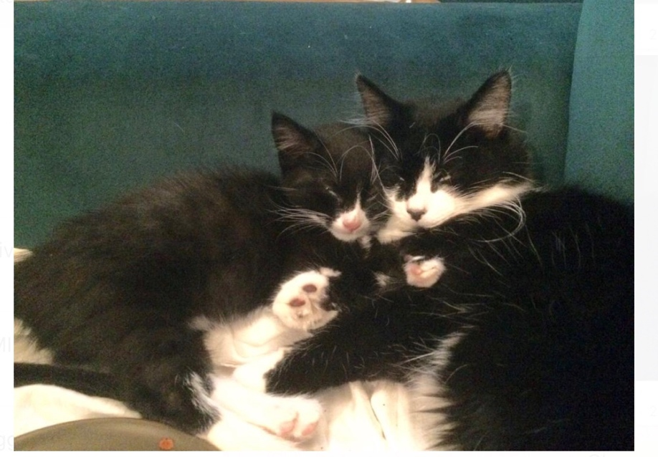
Here is a photo of them having a cuddle!

Tia does not seem to mind Bear eating most of the food and just waits patiently until he has finished. They are brother and sister which means they are siblings. Bear is really really friendly and Tia is more timid.Do you know what timid means? Tia is really fluffy and Bear has much shorter fur .Can you think of a time you have been patient and waited for something this week? It’s good to be patient and say “It’s ok, I really don’t mind waiting!” Here is a challenge for you! Count how many times today you can say these words to people in your family!
Can you tell which cat is Bear and which cat is Tia?
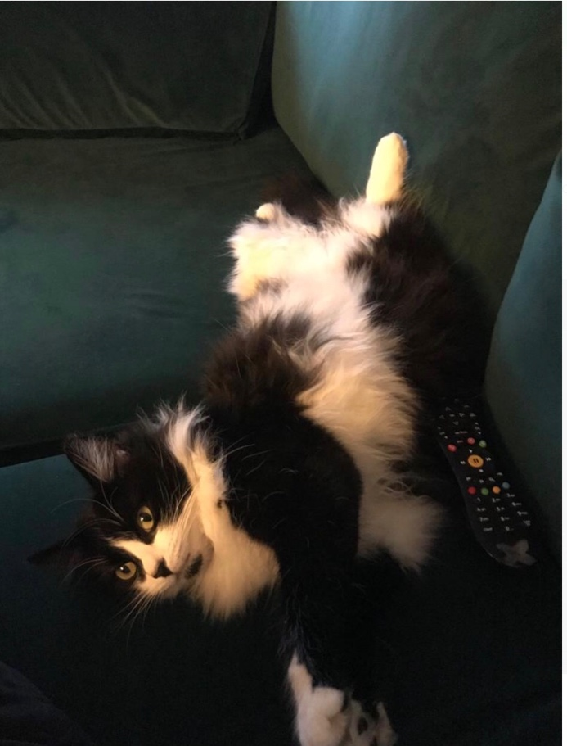
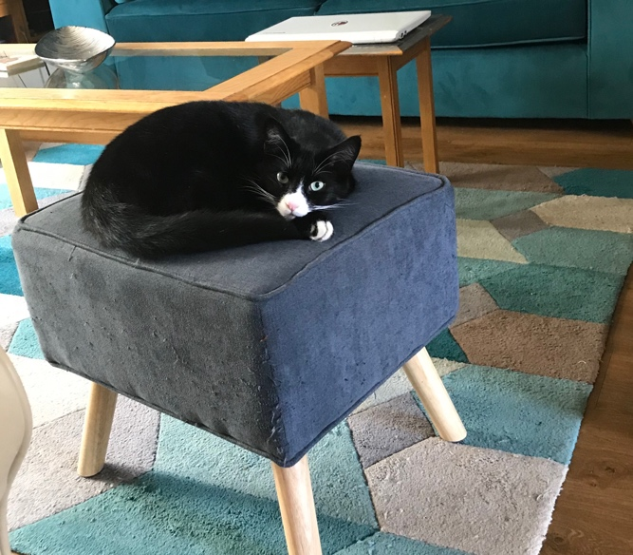
Mrs Bradshaw has really enjoyed being in school and seeing the teachers and children. At home she has been busy painting and making, (anything that is messy). She has been loving her walks with Fonzie and has spotted many unusual birds and plants. She always takes her camera with her and takes a lot of photos. Here is a photo from her walk yesterday, she took it while Fonzie was having a rest in the grass. What flowers can you see?
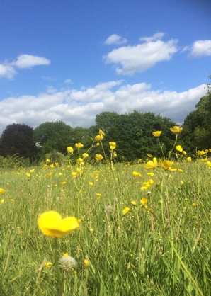
Mrs Bradshaw then received a photo from her sister who was also on a lovely walk at the same time on Wimbledon common and she had spotted this amazing bird. It came really close. Do you know what it is called? She was so lucky! 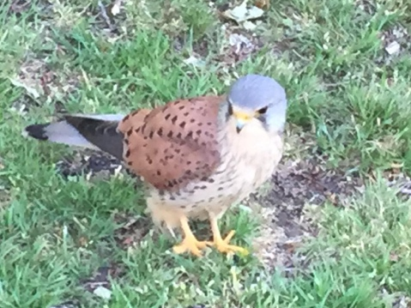
Mrs Bradshaw is delighted her seeds are growing. Some are growing faster than others but the pumpkin seeds she planted from last year’s reception pumpkin are looking super, just like Mrs Watkins parsnips. She will now plant them in a bigger tub so they can grow even more. Maybe they will be giant pumpkins! 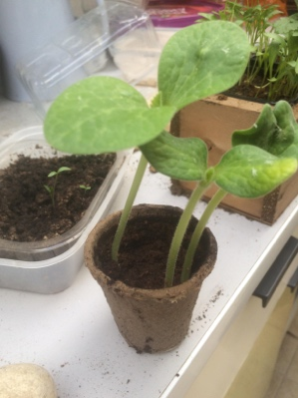 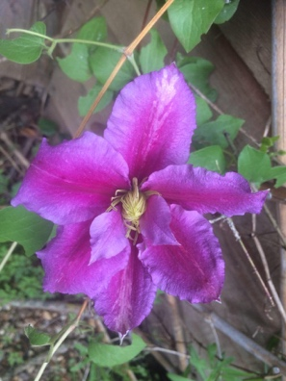
Mrs Bradshaw had a lovely surprise when she found a tiny clematis in her garden. Do you think the flower is the same colour as the one growing in Mrs Suggitt’s garden? Do you see bright colours on your walks or in your garden?
Please all stay safe, happy and healthy, keep smiling! We can’t wait to see you all again soon.
From the Reception Team

