Year 2 home learning w/c 06/04/2020 and 13/04/2020
ENGLISH
Reading
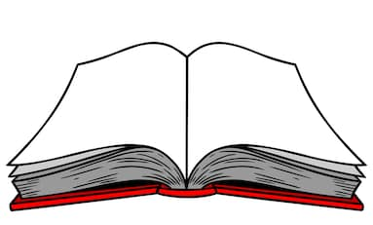
Try and read aloud for 15 minutes a day. Try and read a variety of books. You could also listen to some stories being read aloud using the website blow:
https://www.storylineonline.net/
You could create a bookmark, perhaps you could choose characters from your favourite stories.
You could complete a book review on one of the books you have read -what did you like about it? Would you recommend it to anyone?
Read a fiction book and answer these questions in your workbook.

Try and record what you have read in your Reading Record.

Phonics
Log onto Phonics Play. You can set up free access to it at home during this time. https://new.phonicsplay.co.uk/ Username: march20 Password: home
When you have logged on click on INTERACTIVE RESOURCES-PHASE 5.
Please could you use Buried Treasure, Picnic on Pluto and Dragon’s Den to practise words with aw, ay, ou and ie. Once you have selected the game press on phase 5 and select one of the graphemes. You could play one grapheme each day.
Can you write some silly sentences with some of the following words in your workbook:
yawn law say tray spray play mountain cloud tried replied cried

Spelling
Mr Clumsy makes a lot of mistakes! Even though he’s really trying hard with his writing, he’s still accidentally misspelt some words. Can you help Mr Clumsy and correct his mistakes? You might want to rewrite it out in your workbook.

Th weather wus so beutifull tuday that we were allowed to stay outside for ower art lesson. We sat on the gras and looked at preety, colourful flowers. I had a plante that looked like it was made from gowld because the sun was shining on it. There were lots of wilde flowers in our forest. I hope we do a lesson like that agen soon.

Grammar
Below you will see a range of sentences. Read each sentence carefully. Copy each sentence in your workbook and circle the adjectives, nouns or verbs in each sentence.
Warning: Some may have 2 or 3.
Circle the adjectives in these sentences.
The huge, grey seagulls were flying quickly.
Miss Andrews ate a delicious sandwich for her lunch.
The yellow sun was shining in the clear sky.

Circle the nouns in these sentences.
Mr Monk climbed into his wooden boat quickly.
The cats slept on the soft bed.
Miss Andrews went to London.
Circle the verbs in these sentences.
The butterfly landed on the beautiful flower.
It flapped its wings quickly.
The tiger roared loudly.
Can you improve these sentences? You might be able to add some adjectives or improve the verb. You can write them in your workbook.

The dog walked across the beach.
The children played.
The sun was in the sky.

Handwriting
Have a go at copying these words into your workbook. Remember neatest handwriting!

Writing
‘I couldn’t believe my eyes when I woke up and saw a space rocket in my front garden!’
Can you carry on writing the story? You can write it in your workbook.
You might want to talk about:
Where would you go?
What does it look like?
What’s the weather like?
Do you meet anyone?
Do you meet any problems along the way?
How do you find your way back home?

