Week starting: 22nd June 2020
Dear Reception
Another Friday, the weeks are just flying by! We all hope you have had another very happy week. It has been lovely seeing many of you in school but for those that are still at home we hope you are continuing to have lots of fun and still enjoying the hour’s daily exercise.
Hopefully, you will have looked at some of the ideas for learning about the ‘Sharing a Shell’ and have been enjoying some of the activities. Please do not panic if you have not and please remember these are NOT obligatory! We will continue to send home ideas around the topic we are learning in school for you to try at home.
We are continuing our theme this week with the story of ’Tiddler’ by Julia Donaldson, you can see this story on https://www.youtube.com/watch?v=pBRT5vsfE3U. We will be thinking about the characters in the story and painting our favourite character and then writing about them.
Again for this week, we can’t emphasise enough, one of the most important and best things to do is to keep reading as much as possible. Remember to keep practising your phonic sounds and tricky words and the website for ‘Phonics Play’ is https://new.phonicsplay.co.uk/ which has lots of fun games on it. Also the resources on Espresso are very good for phonics as well.
Obviously learning numbers is also very important, so keep practicing your number writing and remember to make sure they are formed correctly.

In school we will be looking at data collection and how we can display information that we find. In school we are going to find the most popular type of fruit within the children in the bubbles. You could do this at home by asking all your family members. We will then be making a picture graph, just like we did for the noodle tasting and the pumpkin soup.
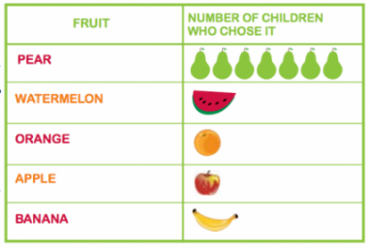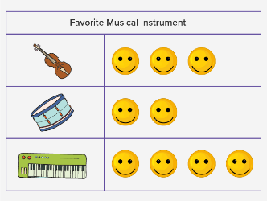
When you are outside keep looking for all the different wildlife that is around and use your notebook to keep a record of the things you see. Remember to keep watching the fox cubs, badger cubs, the ducklings and the tawny owlets at ‘Wildlife Aid’.

Carry on enjoying PE with Joe Wicks or use ‘Just Dance’ to dance along with. Most importantly though, have fun and keep smiling.

The Reception Team

Here are ideas for you this week.
You could……..

Read or listen to the story.

Paint or draw your favourite character from the story.

Can you use your adjectives about your character to write an exciting sentence?

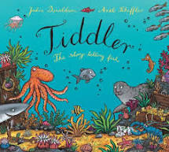 Write adjectives (describing words)
about your character

Can you write a fact about a different sea creature?

Can you write a simple subtraction number sentence? 10-4=6

