Dear Reception children,
Thank you to everyone who has sent an email telling us what fun things you have been up to. It is lovely to read them all and to see the photographs and pieces of work. It is also great that so many of you have been busy on ‘Purple Mash’, lots of lovely paintings, writing and photographs. Some of you have had a go at using ‘2create a story’ and ‘2beat’ and it looks like you are enjoying that and some of you have been using ‘Doddle Maths’ also great fun.

Well, last week Mrs Watkins had another very busy week, she has been doing lots of chores around the house, tidying and cleaning which she doesn’t really enjoy but always feels better when they are done. She has been out in the garden weeding around the cabbages, which are now getting quite big. She was a little sad that two of the cabbage plants have been eaten and are now just stalks and then she found lots of tiny caterpillars that had moved onto another cabbage!

Mrs Watkins has done several mornings at Wildlife Aid. It is still very busy with lots of people bringing in animals they have found out and about on their walks. Mrs Watkins worked with the garden birds again, there are so many, some are so small and have come in because whole nests have fallen out of hedgerows or trees and been found. It takes ages to feed them all as some of the incubators can have up to eight tiny birds in each one and the chicks all need to be fed with a pipette individually! Mrs Watkins now knows how hard mother and father birds have to work to feed all the babies that have hatched in the spring.
Mrs Watkins also helped with the magpies and crows, many are still in the hospital and others now in the outside aviaries but they still all need feeding with tweezers. She cleaned out the baby tawny owls and had to weigh them. When weighing them she had to wear special gloves as their talons and beaks are very sharp. Mrs Watkins also helped with the adult buzzards and you have to be careful as they can get very cross.
Remember to keep watching the fox cubs, the badger cubs and the blue tits nest on
https://www.wildlifeaid.org.uk/webcams/
Finally, Mrs Watkins went into school to see how the classrooms are getting on, it is very exciting as they are almost finished. Then on Wednesday she was able to talk with all her colleagues from school as they had an exciting meeting using the computer.
Mrs Suggitt has been meeting with friends for walks, which she says has been a real treat! She has been only meeting one friend at a time because that’s the social distancing new rule. She has been for walks around Meadow Bank and the Nower and has enjoyed seeing some of you out and about! You know who you are! We are all so lucky to live in this beautiful place with all of our open spaces within easy reach. Do you have a favourite place to go around Dorking?
Yesterday she went to the garden centre and has bought some plants to put in her garden. She says she can’t plant them yet as the ground is so very hard. She wonders why that might be?
Anyway, she’s hopes you all have a lovely half term and looks forward to seeing some of you in a few weeks time.
Mrs Bradshaw has been planting sunflower seeds and is hoping to grow some really tall ones outside her house. Some of her neighbours grow them every year and they are amazing. Have you ever seen giant sunflowers? Mrs Bradshaw often forgets to water her plants so hasn’t been very successful in the past, but she won’t give up and hopes to grow some beautiful flowers this year. She has been inspired by all the beautiful plants she has seen on her lovely walks. She was surprised to spot this plant in a tub in her garden looking very healthy. Do you know what tasty fruit grows on this plant?
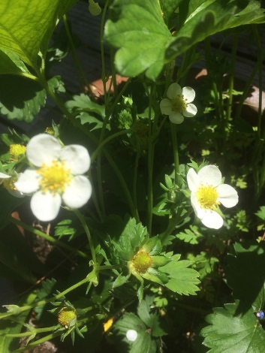
Mrs Bradshaw has been chatting to Mrs Suggitt and Mrs Watkins about getting the new classrooms ready and they are all looking forward to seeing some of you soon. Have a very lovely half term everyone.

Please all stay safe, happy and healthy, keep smiling! We can’t wait to see you all again soon.
From the Reception Team

